Q1

**int minDepth(Node *root)**

**{**

**// Should never be hit unless the code is called on root = NULL**

**if (root == NULL) ---------- 1 marks**

**return 0;**

**// Base case : Leaf Node. This accounts for height = 1.**

**if (root->left == NULL && root->right == NULL) ---------- 1 marks**

**return 1;**

**// If left subtree is NULL, recur for right subtree**

**if (!root->left) ---------- 1 marks**

**return minDepth(root->right) + 1;**

**// If right subtree is NULL, recur for left subtree**

**if (!root->right) ---------- 1 marks**

**return minDepth(root->left) + 1;**

**return min(minDepth(root->left), minDepth(root->right)) + 1; ---------- 1 marks**

**}**

Q2

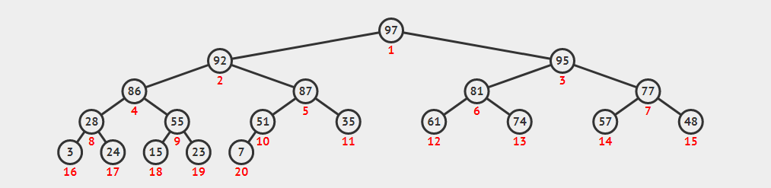

92 was third maximum

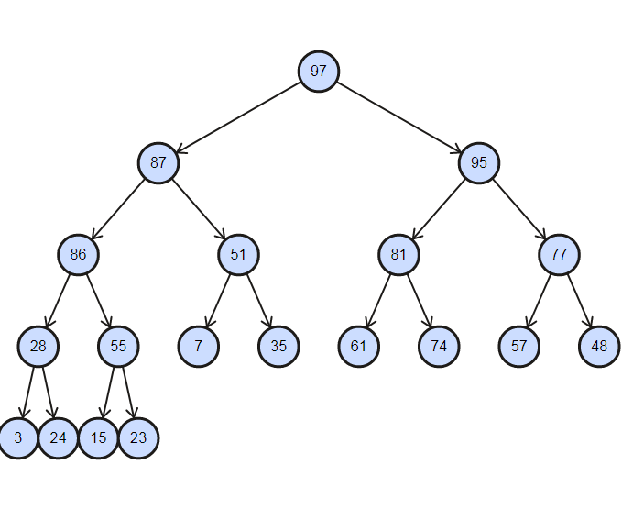

Identify 92 +Changing elements in array + Non Chenging elements in array ---------- 1+2+2 marks

|  |  |  |  |  |  |  |  |  |  |  |  |  |  |  |  |  |  |  |  |
| --- | --- | --- | --- | --- | --- | --- | --- | --- | --- | --- | --- | --- | --- | --- | --- | --- | --- | --- | --- |
| 97 | 92 | 95 | 86 | 87 | 81 | 77 | 28 | 55 | 51 | 35 | 61 | 74 | 57 | 48 | 3 | 24 | 15 | 23 | 7 |
| 97 | 87 | 95 | 86 | 51 | 81 | 77 | 28 | 55 | 7 | 35 | 61 | 74 | 57 | 48 | 3 | 24 | 15 | 23 |